**Module 6 - Portfolio Milestone Project**

**Online Shopping Cart**

Overview:

To build a python program that can simulate an online shopping cart.

Principles:

* Create online shopping class as skeleton so that you can create objects of that class later.
* Reusability – the methods should be reusable.
* Ease of use
* Reuse the class that I built in module for adding items.

Lessons learnt.

* I loved working on this project specially while creating different modules for add/ remove and modify items.
* My concepts of object properties became clear speacially while checking in if clause I was checking for the whole object instead of checking for the element itself.
  + E.g. initially I was doing like this ***- if item == ItemName:***
  + Correct way to check is ***- if item.item_name == ItemName:***

Challenges faced.

* While writing the modify method I faced issue while updating the items
* The description says modify only if default values are not available.
* So modify wont work if at all you want to change the description or qty or price if default values are already present.

How I overcame the above challenges.

* I have added an override class that can change the quantities also in modify method or if you want to keep the same you can just pass by pressing enter.

Program –

* Since this is a big program, I will provide the py file separately

Execution-

* Menu

* Add to cart.
  + Adding 2 items – Microsoft surface Go 2 Laptop 13” and surface headphones

* Show cart.

* Show description.

* Change item .

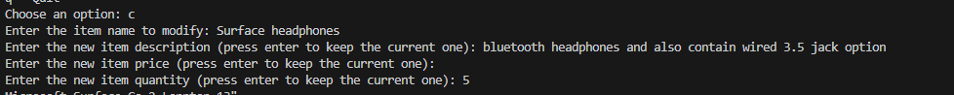

Result

* Remove



Result

* Quit

Git path - <https://github.com/ArunSaxena200/SchoolPython/blob/main/Module6_list_dictionary/PortfolioMilestone_OnlineShoppingCart.py>

Thanks,

Arun